FB03-DISPLAY FI DOCUMENT - DISPLAY FI DOCUMENT FOR TAX PERM RECLASSIFICATION


This simulation describes how to find FI documents posted for Tax Permanenet Difference Reclassifications via T-code FB03. Click to continue.

Explanation | Screenshot
[1] FB03 is now entered in the Transaction box. | 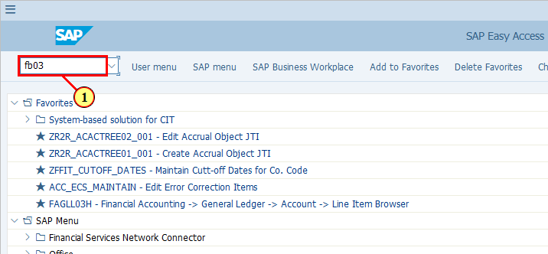
[2] You may also enter the individual document number in the "Document Number" field if you know the document number. This simulation will now describe how to find such documents if you do not know the document number.  Click on Document List. | 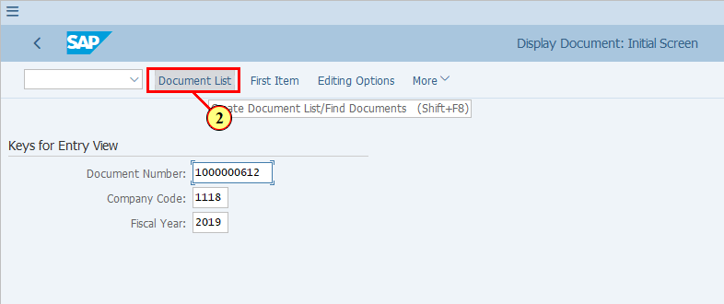
[3] Enter your company code in Company code field. | 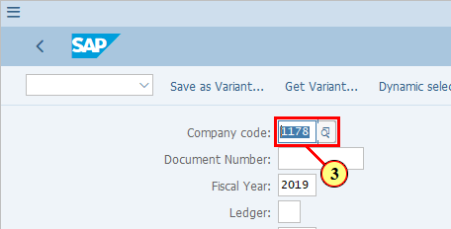
[4] As Tax Permanenet Differences reclassifications are posted to Leger Group T1 only, we need to fill the Ledger Group field with T1. | 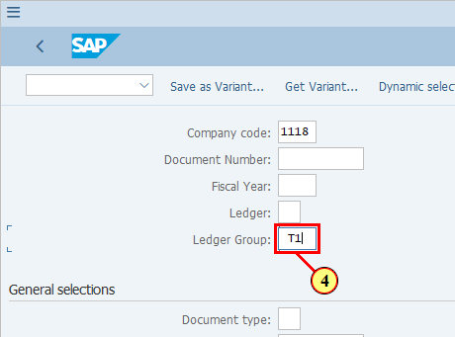
[5] To limit the number of records that the system needs to process, restrict the Fiscal Year selection by entering the fiscal year in which you are looking for the Tax Permanenet Difference reclassification entries. | 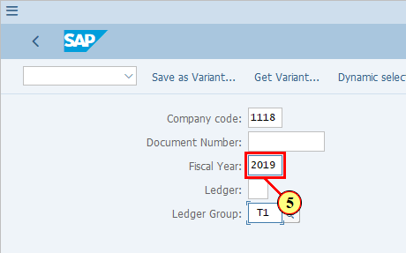
  Enter a posting date range if you know. You may leave Fiscal Year field blank if you use the Posing Date selection. If you use both, make sure your Posting Date range is within the selected Fiscal Year.  You may use other selection criteria if needed. | 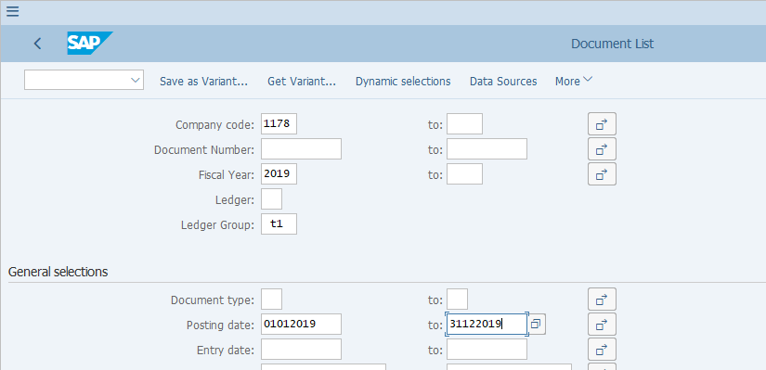
[6] Click Execute .  You can also press F8. | 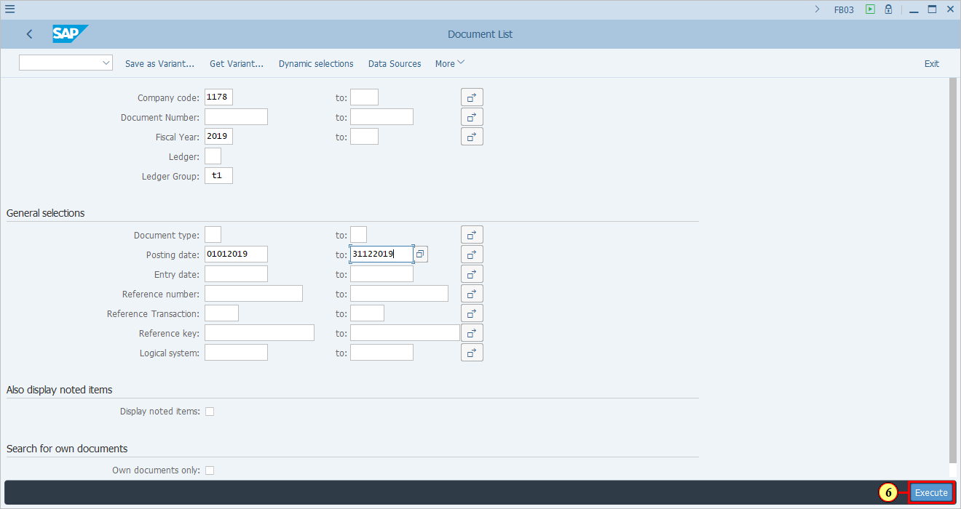
[7] Make sure your layout has the field Ledger Grp. All Tax Permanent Reclassification postings are made to Ledger Group T1. | 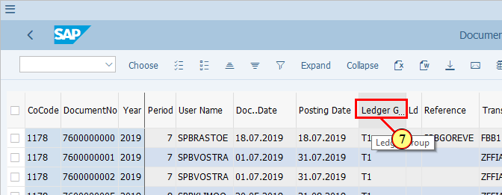
[8] Make sure you have Document Type in your layout. All Tax Permanent Difference Reclassification documents are posted with Document Type YP. | 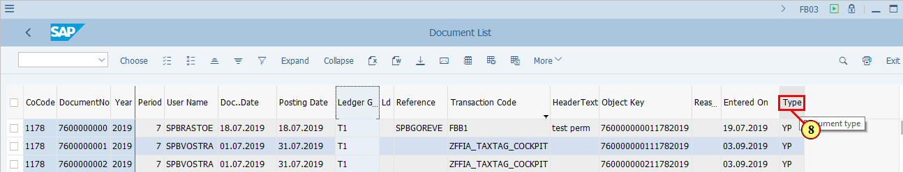
[9] You can also use field Transaction Code to identify the Tax Permanenet Difference Reclassification documents. They are either posted via Tax Perm Tagging Cockpit (T-code ZFFIA_TAXTAG_COCKPIT) or MyRequest GL Journal upload (T-code FBB1). | 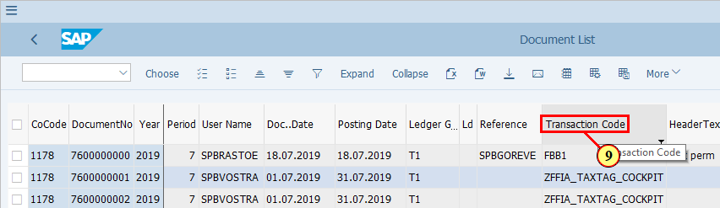
[10] If you need to add more fields, click Change Layout... .  You can also press Ctrl+F8. | 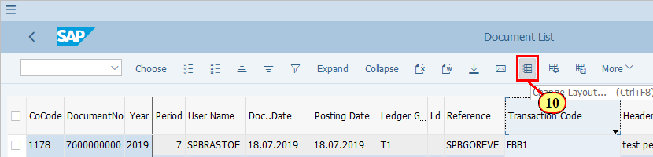
[11] To see details of a selected document, double click the DocumentNo. | 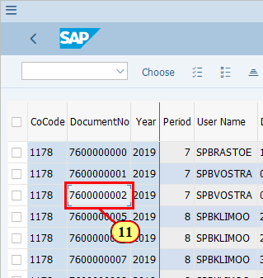
 | 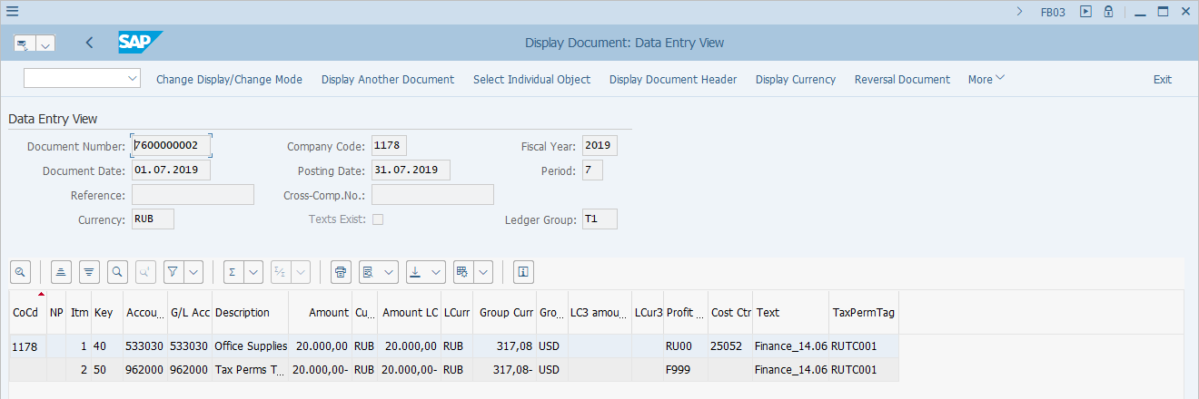
  You should notice that the Ledger Group is T1 for such documents. | 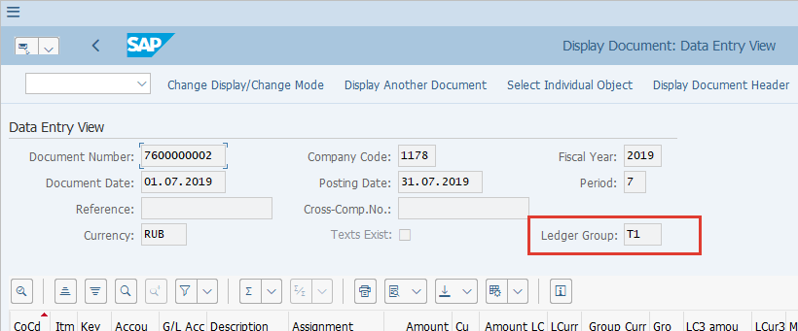
[12] Click More . | 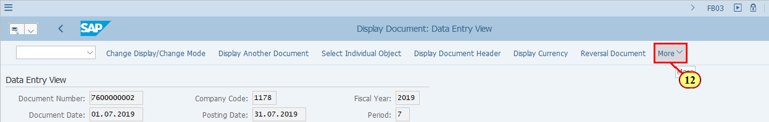
[13] Clicking the General Ledger View Ctrl+F9 menu item executes it. | 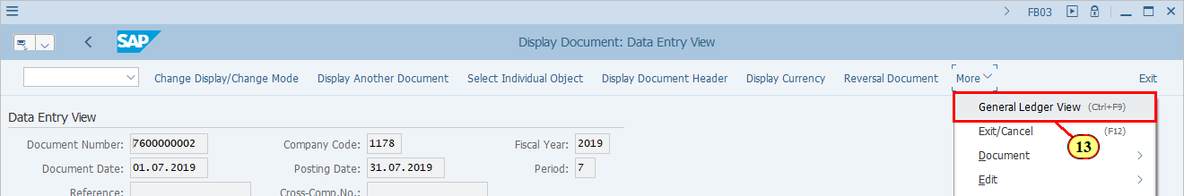
  You now see the Ledger View of this document, which contains only one Ledger T1 as only Ledger T1 belongs to Ledger Group T1. | 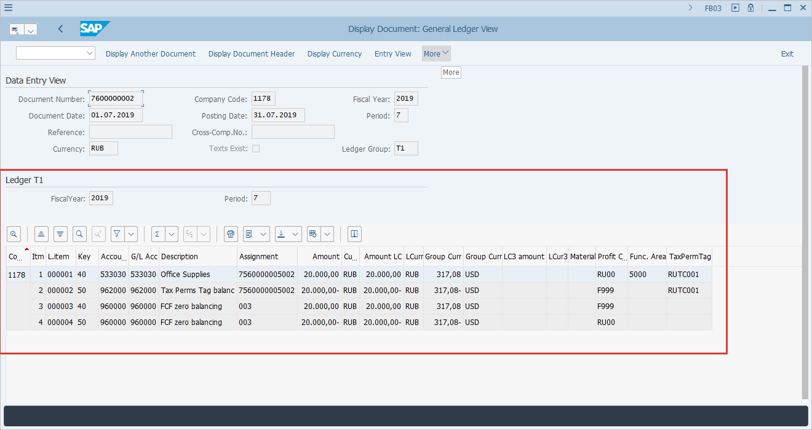
[14] Take note of TaxPermTag field. All Tax Permanent Difference Reclassification documents have this field filled with a valide Tax Perm Tag. | 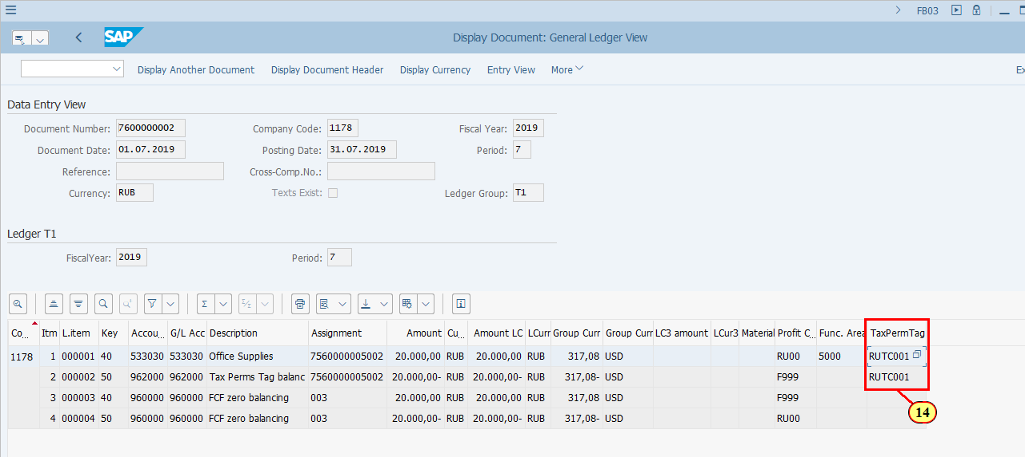
  You may also validate other key information in the Tax Permanenet Difference Reclassification document, such as "Assignment" field, which shows the original FI document and line item number recording the P&L, the posting date/document date, currency, etc. | 